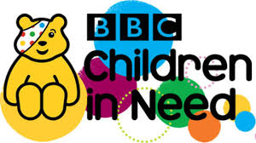

FRIDAY 15TH NOVEMBER 2019

FANCY DRESS DAY

PLEASE BRING A £1.00 DONATION – ALL PROCEEDS WILL GO TO THE CHILDREN IN NEED APPEAL

There will be a prize for the best homemade costume in EYFS (Nurs/Rec), KS1 (Y1/2), LKS2 (Y3/4) and UKS2 (Y5/6).

